CFH at Work at East End Mobile Home Park

This Owner had to remove his enclosed porch Residents have put up with piles of dirt. Every
to allow equipment to get behind his unit to car and mobile home is covered with red dust.
Install the new pipes.

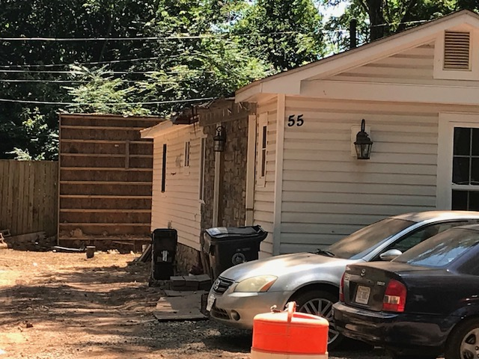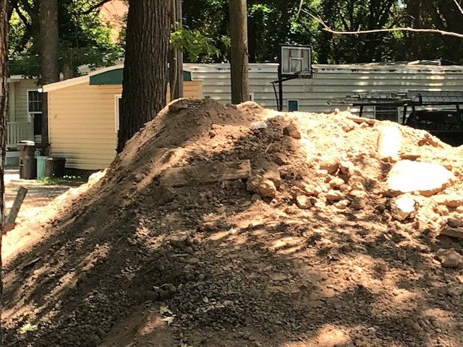

Piles of old cement and debris have been seen Families still grew flowers around the piles of
all over the Park during construction. dirt.

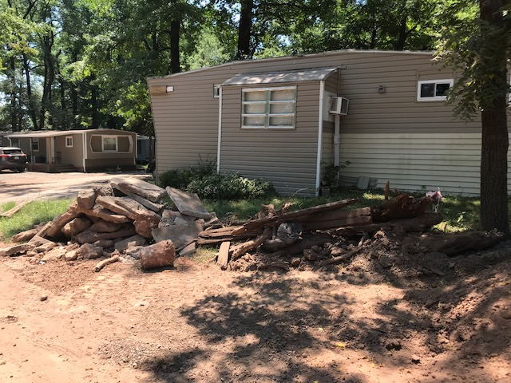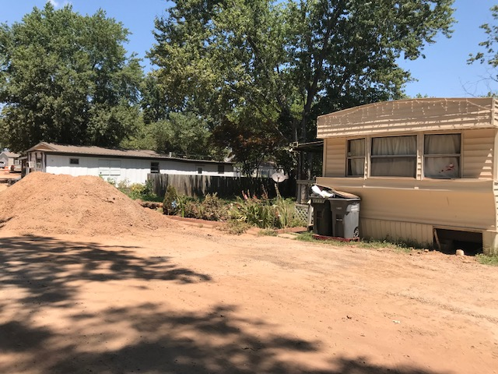

This Owner had put off remodeling and making The Owner is repairing their storage shed just to
Repairs until they were sure they could stay. the left of the mobile home.

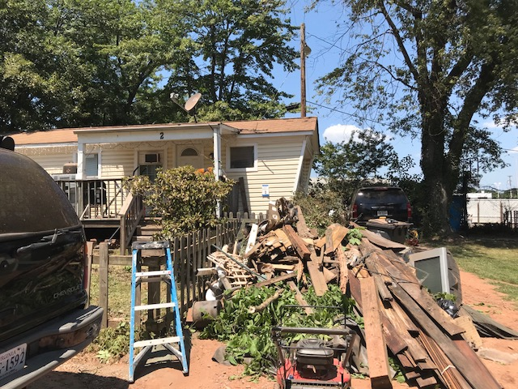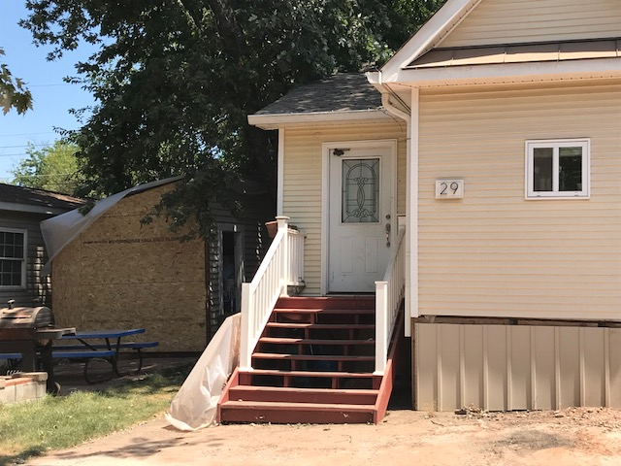

This was an abandoned home that was transferred to CFH upon acquisition. CFH sold it to a young man
Who is going to college and working; he and his Dad are totally remodeling – from new siding to new
windows to a completely new interior, including new kitchen and new bath.

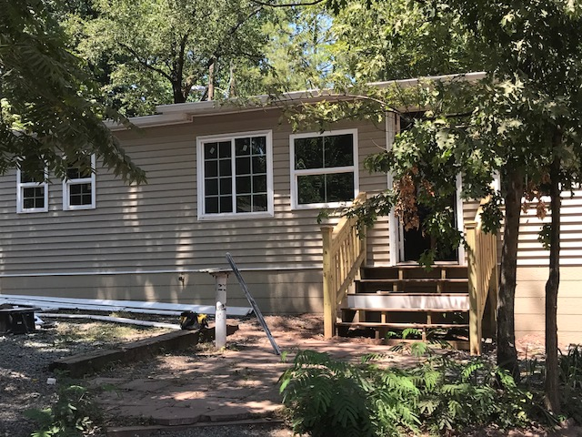

This is home!!! This is home!!!

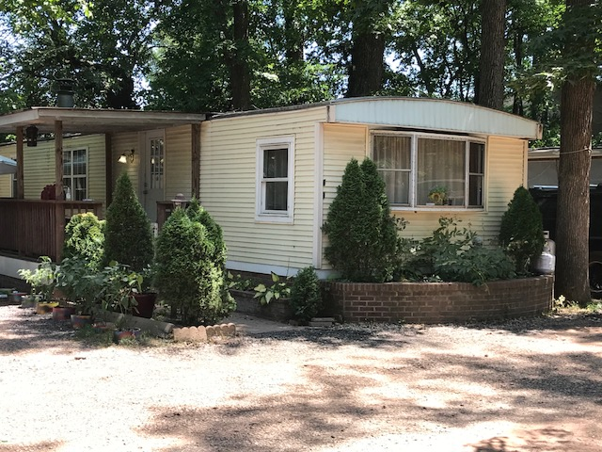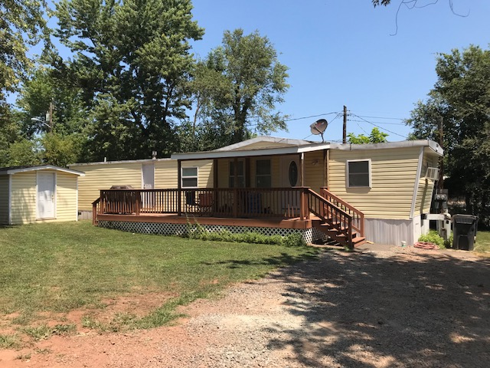

This is home!!! This is home!!!

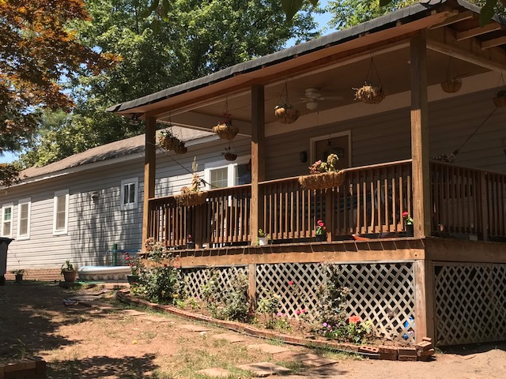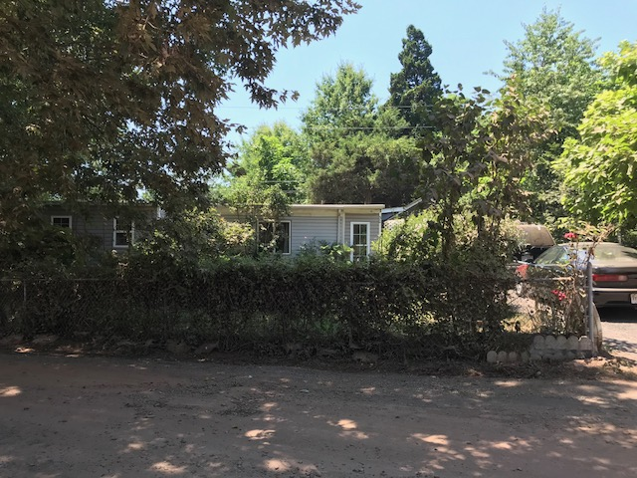

This is the future of East End – CFH envisions remodeling this little building to allow us to
host eductional workshops enhancing the skills of this working community.

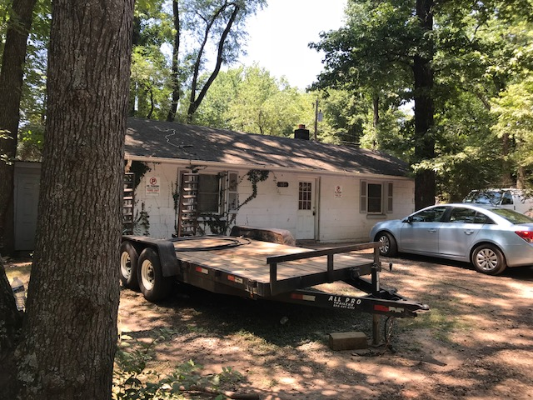

CFH – Catholics for Housing
www.cfhva.org
info@cfhva.org
703-221-4510

