Sponsorship Levels

Signature Sponsor

$10,000
Two Complimentary tables for twenty guests with logo displayed at table.
Branding on all promotional materials, at event, and on invitation if received by June 1, 2018
Full Page Ad in program.
Acknowledgement of sponsorship on CFH website with a link to your company website
Acknowledgement of sponsorship during the evening
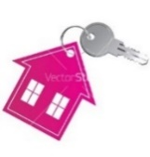
Scrolling Media Board message throughout the evening.

Home - $7,500
Complimentary table for ten guests with logo displayed at table.
Branding on all promotional materials, at event, and on invitation if received by June 1, 2018.
Full Page Ad in program.
Acknowledgement of sponsorship on CFH website with a link to your company website.
Acknowledgement of sponsorship during the evening.

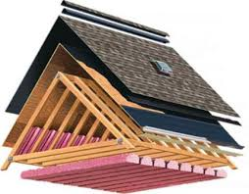
Roof - $5,000
Complimentary tickets for six guests with logo displayed at table.
Branding on all promotional materials and at event.
Full Page Ad in program.
Acknowledgement of sponsorship on CFH website with a link to your company website.
Acknowledgement of sponsorship during the evening.

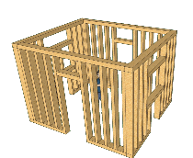
Wall - $2,500
Complimentary tickets for four guests with logo displayed at table.
Branding on all promotional materials at event.
Half Page Ad in program.

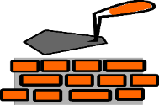
Foundation - $1,250
Complimentary tickets for two guests
Branding on all promotional materials at event.
Quarter Page Ad in program.

All donations $250.00 and above received by August 31, 2018 will be listed in the program as Neighbors.

COMMITMENT FORM – PAYMENT BEFORE AUGUST 1, 2018

Name of Company or Organization:

Mailing Address:

Contact Name:

Contact Phone: _____________________ Contact Email:

Sponsor Level

Name of your organization as it is to appear in the event literature and PR Materials:

Email Photo-Ready Art to info@cfhva.org by August 31, 2018

Preferred form of Payment: Check Master Card Visa

Credit Card #: ___________________ Exp. Date: CCV#_____

Full Name on Credit Card:

Payments must be made by August 1, 2018
Commitments received after August 1, 2018 will not be published in program.

If paying by check, please make payable to: Catholics for Housing, Inc.
Mail check and form to: 18139 Triangle Shopping Plaza, Suite 209
Dumfries, VA 22026-2582

If paying by credit card, fax form to: 703-221-3708 – Questions call 703-221-4510

