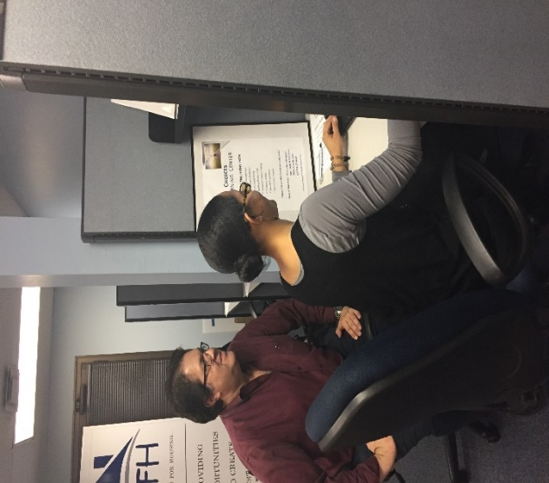­

CFH also offers these programs to eligible applicants:

* Security Deposit Assistance
* Senior Rental Assistance (Fairfax Only)
* Down Payment Assistance (Limited Areas)
* Rental Opportunities
* Homeownership Opportunities
* Life Skills

**CFH PROGRAMS**

www.cfhva.org

18139 Triangle Shopping Plaza

Suite 209

Dumfries, VA 22026

(703) 221-4510

**ABOUT CFH**

Catholics for Housing (CFH) is a non-denominational, non-profit organization with 40 years’ experience in creating affordable housing opportunities for limited-income families.

Our offices have been in Prince William County since 2003 and we have created two affordable housing developments in Prince William County for first-time homebuyers.

CFH is a regional organization with a primary focus in Prince William, Fairfax and Arlington Counties, and the city of Fredericksburg.

CFH provides programs to eligible applicants in a non-discriminatory manner without regard to race, creed, age, familial status, religious affiliation, gender or ethnicity.

**CHANGE YOUR CHOICES**

**CHANGE YOUR LIFE.**



**703-221-4510**

Schedule your free 30 minute

personal consultation today!

**Choose the right path**

**CHOICES**

Choices Learning Center

**CHOICES LEARNING CENTER**

The CFH Choices Learning Center provides opportunities to:

* Search for jobs
* Submit applications
* Enhance your skills
* Complete Choices classes

**FINANCIAL MANAGEMENT**

* Analyzing spending habits
* Budgeting
* Fulfilling contracts

**EMPLOYMENT READINESS**

* Successfully completing applications
* Writing an effective resume
* Developing strong interview techniques
* Building succesful habits for employees

**PHYSICAL WELL-BEING**

* Caring for self and family

**BUILDING GOOD RELATIONSHIPS**

* The importance of various types of relationships
* Building good relationships through effective communication

**WHAT IS CHOICES?**

Currently the Center is open three days a week

Monday 3 PM - 7 PM

Tuesday 10 AM - 12 PM

Thursday 1 PM - 5 PM

**HOURS**

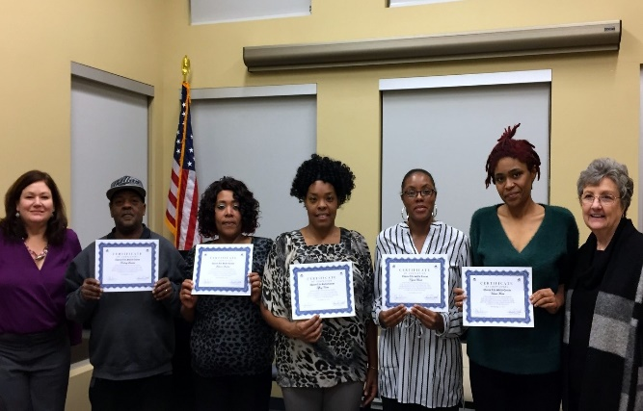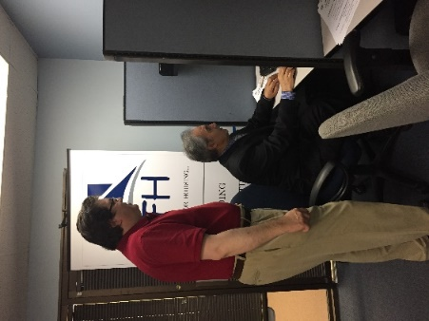

**train the trainer**

**sessions also available**

Being a successful employee is

an important factor in achieving

dreams, therefore Choices is

available before or after work.

**Choices offers the tools   
to make good decisions  
today to help achieve  
goals and dreams  
for tomorrow.**

Call for your Free Personal Appointment Today!

**(703) 221-4510**

**CALL**