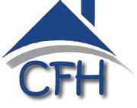
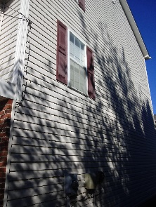
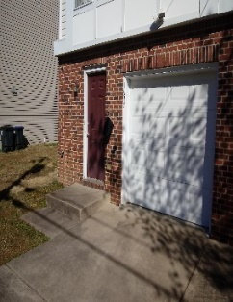
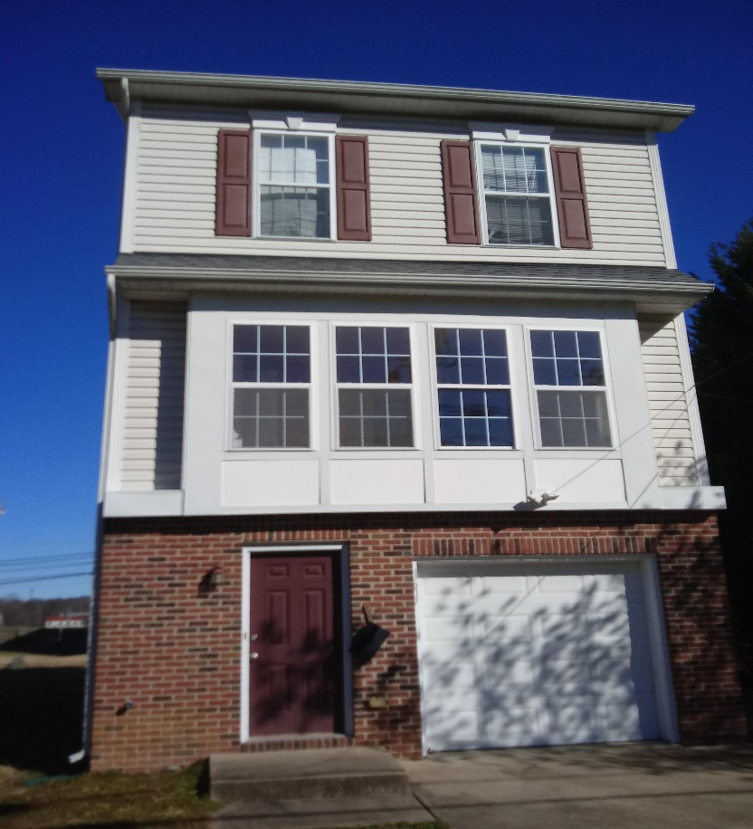
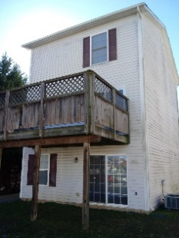
1617 Airport Avenue
Fredericksburg, VA 22401
Close to Dixon Park
Accessible to Downtown Fredericksburg
Less than 2 miles to the Virginia Railway Express
Proximity to
Central Park Shopping
&
Spotsylvania Towne Centre
Expected Availability Early Summer 2021
Price Range
$230,000 – $250,000
3 Bedrooms with a Bonus Room
2 Full Baths & 2 Half Baths
1 car garage
Deck
Renovations to include new roof, updated kitchen & appliances, freshly painted, power-wash

appliances, paint, fixtures, power-wash.
703-221-4510
Share this Brochure with your Mortgage Loan Officer

703-221-4510
info@cfhva.org
First Guardian Title & Escrow Share this brochure with your
12660 Lake Ridge Drive Mortgage Loan Officer
Lake Ridge, VA 22192
703-494-4000 2% Commission to buyer Agent
Eligibility Requirements
First Time Homebuyer
Pre-Qualified Buyer
Attended a VHDA approved Homebuyer Class
Income Below 80% of the Area Median Income
$82,300 (4 person Household)
https://www.vhda.com/BusinessPartners/PropertyOwnersManagers/Income-Rent-Limits/Pages/HUDMedianIncome.aspx
VHDA Eligible Mortgage Contacts
Special Financing and Down Payment Assistance may be available, at these lenders, if qualified.
VHDA Approved Lenders
Lisa Perry, Senior Loan Officer Joann Farmer, Loan Officer
First Home Mortgage Movement Mortgage (Fredericksburg)
jperry@fhmtg.com joannfarmer@movement.com
540-273-2733 or 703-259-8633 540-220-4925
Additional VHDA approved lenders can be found at
https://www.vhda.com/Homebuyers/FindALender/Pages/TPLO-NVA.aspx
Housing Counseling Agencies
First Home Alliance, Inc., Central Virginia Housing Coalition
3138 Golansky Blvd, Suite 202 2300 Charles St.
Woodbridge, VA 22192 Fredericksburg, VA 22401
703-580-8838 540-604-9949
Additional housing Counseling Agencies can be found at: https://apps.hud.gov/offices/hsg/sfh/hcc/hcs.cfm
VHDA Homebuyer Workshops
https://www.vhda.com/Homebuyers/HomeownershipEdu/Pages/HomeownershipEdu.aspx

