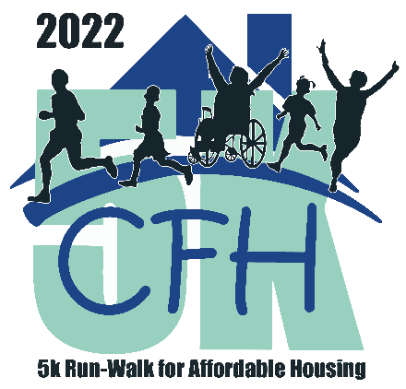

AUGUST 2022

Dear Sponsor,
Please join us as we come together and celebrate our annual event, 5K-Run-Walk for Affordable Housing to raise awareness and funds to increase affordable housing. Please save the dates from October 23-November 6, 2022. All donations and proceeds raised from this event will fund our continuum of housing programs including rental, security deposit assistance, homeownership programs, senior citizen assistance and a mobile housing park.
This year, the race kick-off will be on Sunday, October 23, at the Occoquan Regional Park, 9751 Ox Rd, Lorton, VA 22079, USA. The virtual race will continue through November 6, and participants will be able to walk/run individually or as a part of a team at their location and at their convenience. We are requesting that participants post their pictures online. Registration and detailed information will be received through the CFH race page at cfhva.org.
CFH was founded by Father Gerard Creedon and a group of Catholic parishioners in 1979. The race will be in his honor. CFH has worked more than four decades to provide a continuum of housing opportunities and help individuals and families along a path of self-sufficiency. CFH’s direct-service programs provide security deposit assistance, senior assistance, and down payment assistance for those who qualify. In addition, CFH owns and manages 16 rental units for the local workforce and continues as a co-owner of its original apartment complex in Vienna, serving 30 households. CFH also owns and operates a 60-unit mobile home park as well as providing homeownership opportunities and a comprehensive life skills program to enhance the skills of the participants.
CFH is a charitable 501c(3) organization and the proceeds will go towards our much needed programs. We kindly request your sponsorship to ensure the continued success of CFH’s programs. Please find enclosed the sponsorship opportunities for your consideration.
18139 Triangle Shopping Plaza,
Suite 209 | Dumfries, VA 22026
Please contact me at george@cfhva.org or 703-221-4510.

Thank you for your consideration,
George Davies

Donors who give to CFH through June 30, 2023, qualify for an extra state tax benefit. When you personally donate a minimum of $500, you can write off up to 65% of that on your state return. When your business or organization donates a minimum of $616, it will benefit from a 65% tax credit on its state return as well.

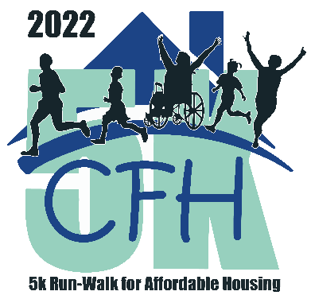
CFH 5K Run-Walk for Affordable Housing
In memory of Rev. Gerard Creedon
2022 Sponsorship Levels
October 23-November 6, 2022 A Live & Virtual Event
The ONLY CFH Fundraising Event in 2022,
So Please Give Generously!
Proceeds Will Provide Much Needed Assistance to
Our Neighbors Who Need it Now More Than Ever!

TOP LEVEL - $5,000 (Title Sponsor)
- Event “Presented by” [Title Sponsor] positioning on all event communications and promotions
- Name & logo displayed in opening event starting line graphics
- Name & logo presented on banner ad on CFH homepage with link to sponsor website
- Year-long recognition on CFH website
- 6 social media posts
- Name prominent on event T-shirt
- Logo displayed on event registration page
- Invitation for Company Principal to speak during the opening ceremony of live event at Occoquan Regional Park in Lorton, Virginia
- Option to include sponsor marketing materials in registration packets
- 10 event registrations

PLATINUM - $4,000 (Level 6)
- Logo displayed in event communications and sponsorship listings
- Name on event T-shirt
- 4 social media posts
- 6 month-long recognition on CFH website with link to sponsor website
- Option to include sponsor marketing material in registration packets
- 8 event registrations

DIAMOND - $2,500 (Level 5)
- Logo displayed in event communications and sponsorship listings
- Name on event T-shirt
- 4 social media posts
- 3 month-long recognition on CFH website with link to sponsor website
- Sponsor name on T-shirt
- Option to include sponsor marketing material in registration packet
- 4 event registrations

GOLD - $1,000 (Level 4)
- Name displayed in event communications and sponsorship listings
- 2 social media mentions
- Recognition on CFH website
- Sponsor name on event T-shirt
- 3 event registrations

SILVER - $500 (Level 3)
- 1 social media mention
- Recognition on CFH website
- Sponsor name on event T-shirt
- 2 registrations

BRONZE - $250 (Level 2)
- 1 social media mention
- Name displayed in event sponsorship listings
- 1 registration

FRIEND - $100 (Level 1)
- Name displayed in event sponsorship listings

