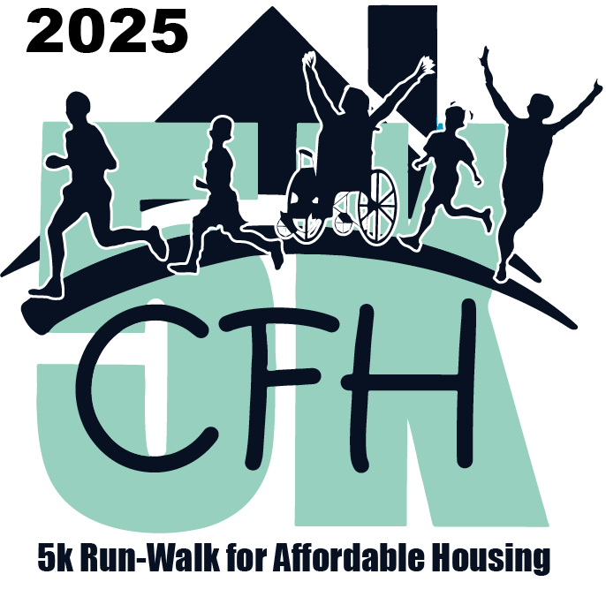8th Annual

CFH 5K Run-Walk

for Affordable Housing

In memory of Father Gerard Creedon

Live: October 5, 2025 @ 9:30 am at Occoquan Regional Park

Virtual: October 5-19, 2025

2025 Sponsorship Levels

Creating Foundations for Hope Since 1979

TITLE SPONSOR - $7,500

• Event “Presented by” [Title Sponsor] positioning on all event promotions

• Name & logo displayed in opening event starting line graphics

• Name & logo presented on banner ad on CFH homepage with link to sponsor website

• Year-long recognition on CFH website

• 6 social media posts

• Name prominent on event T-shirt

• Logo displayed on event registration page

• Invitation for Company Principal to speak during the opening ceremony of live event

• Option to include sponsor marketing materials in registration packets

• 10 event registrations

PLATINUM SPONSOR - $5,000

• Logo displayed in event communications and sponsorship listings

• Name on event T-shirt

• 4 social media posts

• 6 month-long recognition on CFH website with link to sponsor website

• Option to include sponsor marketing material in registration packets

• 8 event registrations

DIAMOND SPONSOR - $2,500

• Logo displayed in event communications and sponsorship listings

• Name on event T-shirt

• 4 social media posts

• 3 month-long recognition on CFH website with link to sponsor website

• Sponsor name on T-shirt

• Option to include sponsor marketing material in registration packet

• 4 event registrations

GOLD SPONSOR- $1,000

• Name displayed in event communications and sponsorship listings

• 2 social media mentions

• Recognition on CFH website

• Sponsor name on event T-shirt

• 3 event registrations

SILVER SPONSOR - $500

• 1 social media mention

• Recognition on CFH website

• Sponsor name on event T-shirt

• 2 registrations

BRONZE SPONSOR - $250

• 1 social media mentions

• Name in event sponsorship listings

• 1 registration

FRIEND - $100

• Name in event sponsorship listings